

Developing frameworks
Review guide

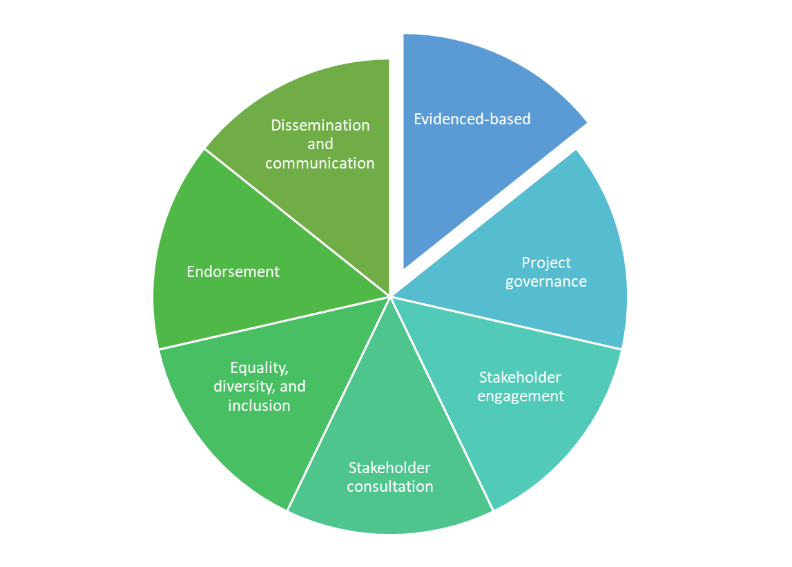
Contents
Introduction 3
Framework review 3
Framework review process 3
Framework review form 4
References 9

Introduction
In this document you will find guidance in relation to reviewing a framework which is based on the NMAHP Development Framework. This document can be used to evidence that the framework being reviewed is following the 10 best practice steps as well as the standardised structure which has been adapted from the Skills for Health report which focuses on guidelines and standards for developing capability and competence frameworks (2022).

This guide is for:
- project commissioners and/or steering groups to ensure a newly developed framework has or is following best practice guidance.

Framework review
Not all frameworks being presented for review may have fully followed the steps and structure within the developing frameworks guidance, however, reviewees can still consider evidence from additional resources and discussion to ensure the framework is evidenced based and that it has followed clear governance processes.

Framework review process
Once the framework has been drafted, the framework should be submitted to the appropriate panel for review.
Within the framework review form (table 1), the author/s or representative of the framework should make comment to supplement evidence.
During the review meeting, the author/s or representative of the framework will take the panel through how the framework was developed.
The review panel will then recommend if further development is required or confirm that the framework meets the best practice steps.

Framework review form

Title of framework: Date of review:
10 steps for developing a framework
Step | Description | Additional comments from framework representative | Achieved
Step 1: Evidenced-based | The framework is based on a review of the current and relevant evidence-base e.g., guidelines, reports, standards, frameworks, qualifications. The rationale and evidence for the development of the framework can be presented within the ‘background and strategic alignment’ section of the framework. |  | ☐
Step 2: Clear project governance | Agreed reporting structures, usually the framework developer to the project commissioner/steering group, and endorsement of the completed framework. |  | ☐
Step 3: Stakeholder engagement | Following initial research and discussion with the project commissioner, key stakeholders should be identified. Key stakeholders may include subject matter experts, practitioners, educators, academics, service commissioners, service managers/leaders, and experts by experience.  Best practice is to set up a project/steering group of 10 to 20 people.  A further stakeholder group may be established to provide a wider reference group. |  | ☐
Step 4: Stakeholder consultation | Steering group to develop a full draft of the framework and share with wider group of stakeholders to seek confirmation or clarification on specific issues and provide opportunity for general comments.  Consultation can range from sharing a survey to holding a workshop with stakeholders.  Following consultation, feedback will be analysed then fed back to the steering group for consensus to be achieved or amendments made to framework. |  | ☐
Step 5: Equality, diversity, and inclusion | Due regard must be given to the need to eliminate discrimination, to advance equality of opportunity, diversity, and inclusion.  The Equality Impact Assessment (EQIA) may be aligned to the NMAHP Development Framework alongside an effective and inclusive consultation. |  | ☐
Step 6: Endorsement | Completed framework to be formatted in accordance with any required branding guidelines.  It is recommended that the NHS Education for Scotland (NES) NMAHP template should be used. |  | ☐
Step 7: Dissemination and communication | Evidence that approaches to communication and dissemination have been considered which may include emails, news pages, web briefings, stakeholders to share across regional networks, social media. |  | ☐
Step 8: Implementation | Evidence that an implementation plan has been considered. The framework is a finished product at this stage.  Plan for promoting and supporting the use of the framework for development of the current and future workforce. This could include the development of any related tools or resources. |  | ☐
Step 9: Impact measurement | Evidence that measuring impact on engagement, education, performance, and service has been considered.  Consider collecting baseline data to measure changing outcomes over time. |  | ☐
Step 10: Review | Consideration should be given to plan for future framework updates and review.  Ownership and date of review will be required. | Ownership:  Review date: | ☐

Final comment from review panel

Date:
Confirmation of ownership and review date
Ownership: Review date:

Recommendation to the Steering Group
Requires further development OR recommend endorsement (delete as required)

Steering Group decision

Date:
Table 1: Framework review form

References

Skills for Health [Intranet]. Standardisation of frameworks; 2024 March 18 [cited 2022]; Available from: Standardisation of Fwks Report FINAL 14 Mar 22.docx (sharepoint.com)

