

Developing frameworks
A guide for developing knowledge, skills and behaviours frameworks

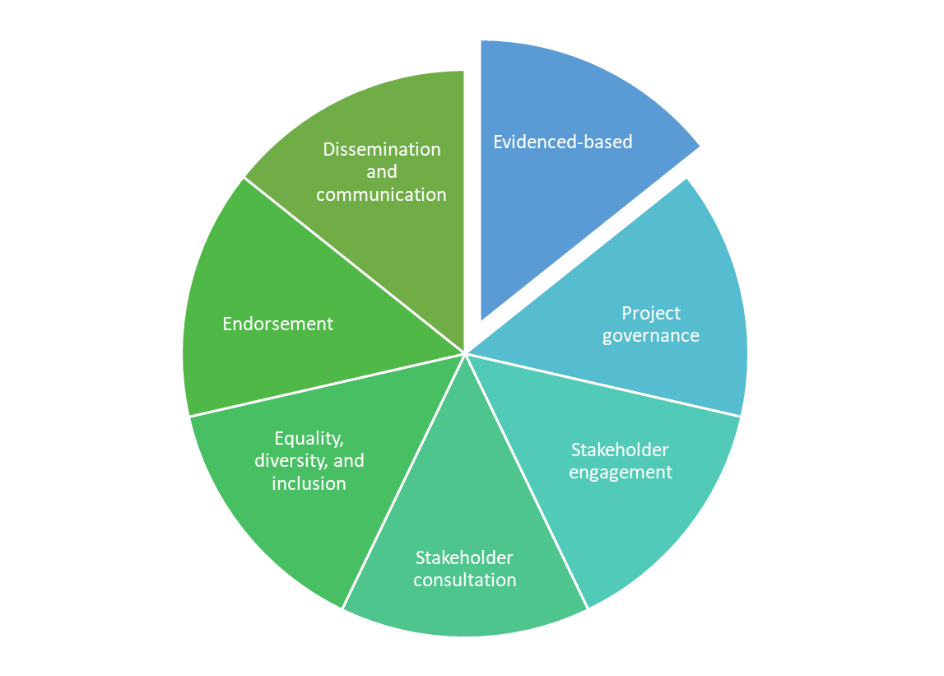
Contents
Introduction 3
Definition of a framework 3
Developing a framework 4
10 steps to developing a framework 4
Structure of a framework 7
NMAHP framework template 10
Framework review 11
References 16

Introduction
In this document you will find guidance in relation to what a framework is, what the steps and structure are for developing and reviewing a framework, as well as access to a template which can be used to support development of a Nursing, Midwifery, Allied Health Professions, Support Workers knowledge, skills and behaviours framework.
This guide is for:
- staff who work in health and social care who are considering development of a framework to support staff development of knowledge and/or skills; and
- for project commissioners/steering groups to ensure a drafted framework has followed best practice guidance.

Definition of a framework
A framework is an evidenced based structure, set of rules, or a flexible schema, which supports learning goals to be aligned. Usually, a framework helps staff to develop the ability to transfer knowledge into practice. Frameworks do not dictate what is taught, and various frameworks serve different ends, addressing different questions of interest.
Frameworks are usually structured around levels and/or components, for example, competencies, knowledge, skills, behaviours, and pillars of practice.
Many of the frameworks in health and social care provide the infrastructure to support learning and development needs of Nurses, Midwifes, Allied Health Professionals (NMAHP) staff working in a range of practice settings. Examples of NHS Education for Scotland (NES) frameworks include the NMAHP Development Framework, the NMAHP Development Framework for Major Trauma Care in Scotland, and the Career Development Framework for Nurse Endoscopists.

Developing a framework
It is recommended that if the framework is specifically for NMAHP staff, then the framework being developed is underpinned by the NMAHP Development Framework. Therefore, the new framework will combine the content from the NMAHP Development Framework with specific content relating to the service area/speciality.
Although this guidance relates specifically to the development of NMAHP staff, it can be adapted for other professions out with NMAHP.

Skills for Health (2022) was commissioned by Health Education England to carry out a review of current frameworks and to create guidelines based on best practice to support the development of frameworks.
Table 1 outlines the 10 best practice steps to be taken when developing a framework as described by Skills for Health (2022).
Table 2 can be used to help structure the framework content being developed which has been adapted from the Skills for Health (2022) standardisation of frameworks.

10 steps to developing a framework
The steps outlined in table 1 will ensure that the framework being developed follows a robust process.
Step | Description | Completed
Step 1: Evidenced-based | The framework is based on a review of the current and relevant evidence-base e.g., guidelines, reports, standards, frameworks, qualifications. The rationale and evidence for the development of the framework can be presented within the ‘background and strategic alignment’ section of the framework. | ☐
Step 2: Clear project governance | Agreed reporting structures, usually the framework developer to the project commissioner/steering group, and endorsement of the completed framework. | ☐
Step 3: Stakeholder engagement | Following initial research and discussion with the project commissioner, key stakeholders should be identified. Key stakeholders may include subject matter experts, practitioners, educators, academics, service commissioners, service managers/leaders, and experts by experience.  Best practice is to set up a project/steering group of 10 to 20 people.  A further stakeholder group may be established to provide a wider reference group. | ☐
Step 4: Stakeholder consultation | Steering group to develop a full draft of the framework and share with wider group of stakeholders to seek confirmation or clarification on specific issues and provide opportunity for general comments.  Consultation can range from sharing a survey to holding a workshop with stakeholders.  Following consultation, feedback will be analysed then fed back to the steering group for consensus to be achieved or amendments made to framework. | ☐
Step 5: Equality, diversity, and inclusion | Due regard must be given to the need to eliminate discrimination, to advance equality of opportunity, diversity, and inclusion.  The Equality Impact Assessment (EQIA) may be aligned to the NMAHP Development Framework alongside an effective and inclusive consultation. | ☐
Step 6: Endorsement | Completed framework to be formatted in accordance with any required branding guidelines.  It is recommended that the NHS Education for Scotland (NES) NMAHP template should be used. | ☐
Step 7: Dissemination and communication | Evidence that approaches to communication and dissemination have been considered which may include emails, news pages, web briefings, stakeholders to share across regional networks, social media. | ☐
Step 8: Implementation | Evidence that an implementation plan has been considered. The framework is a finished product at this stage.  Plan for promoting and supporting the use of the framework for development of the current and future workforce. This could include the development of any related tools or resources. | ☐
Step 9: Impact measurement | Evidence that measuring impact on engagement, education, performance, and service has been considered.  Consider collecting baseline data to measure changing outcomes over time. | ☐
Step 10: Review | Consideration should be given to plan for future framework updates and review. | ☐

Table 1: The 10 steps in developing a framework

Structure of a framework
In this section, recommendations on how to structure frameworks is described with a template to support a consistent framework structure and terminology used. By following the structure within table 2, it will support this consistency across frameworks, and with this, the framework will be easier to be put to practical use.
Some of the subheadings are optional and additional subheadings may need to be created dependent on the service area or purpose of the framework being developed.

Section | Heading | Completed
Section 1: Front | Title | ☐
Section 1: Front | Owner/co-owner | ☐
Section 1: Front | Acknowledgments | ☐
Section 1: Front | Date published | ☐
Section 1: Front | Date for review | ☐
Section 1: Front | Contents page | ☐
Section 1: Front | Foreword/statement of support (optional) | ☐
Section 2: Introduction | Focus of framework | ☐
Section 2: Introduction | Aim and outcomes | ☐
Section 2: Introduction | Background and strategic alignment | ☐
Section 3: Structure of framework | Structure of framework | ☐
Section 3: Structure of framework | Pillars of practice | ☐
Section 3: Structure of framework | Levels of practice | ☐
Section 3: Structure of framework | Levels of practice and pay bands | ☐
Section 3: Structure of framework | Related frameworks | ☐
Section 3: Structure of framework | NHS Scotland’s Values | ☐
Section 3: Structure of framework | Equality and health inequalities statement | ☐
Section 4: Using the framework | Scope of practice | ☐
Section 4: Using the framework | Recording learning and development | ☐
Section 4: Using the framework | Support and supervision | ☐
Section 5: Role, education, knowledge, skills and behaviours | Level 2 Healthcare Support Worker | ☐
Section 5: Role, education, knowledge, skills and behaviours | Level 3 Healthcare Support Worker | ☐
Section 5: Role, education, knowledge, skills and behaviours | Level 4 Assistant Practitioner | ☐
Section 5: Role, education, knowledge, skills and behaviours | Level 5 Practitioner | ☐
Section 5: Role, education, knowledge, skills and behaviours | Level 6 Specialist/Senior Practitioner | ☐
Section 5: Role, education, knowledge, skills and behaviours | Level 7 Advanced Practitioner | ☐
Section 5: Role, education, knowledge, skills and behaviours | Level 8 Consultant Practitioner | ☐
Section 6: Appendices | How the framework was developed (optional) | ☐
Section 6: Appendices | SCQF framework (optional) | ☐
Section 6: Appendices | Assessment of learning and clinical competencies (optional) | ☐
Section 6: Appendices | Glossary of terms (optional) | ☐
Section 6: Appendices | Reference list | ☐
Other | Version control | ☐
Other | Page numbers | ☐
Other | Copyright | ☐

Table 2: Structure of a framework

NMAHP framework template
The purpose of the template is to offer a simple structure to build the framework around.
This framework template is structured in alignment with the steps and structure identified in this document (table 1 and 2), as well as being based on the NMAHP Development Framework. The template focuses on core knowledge, skills, and behaviours required by practitioners working in the service across four pillars of practice at career levels 2-8.

As the knowledge and skills required of practitioners will depend on the service model, this template gives you the opportunity to record additional relevant knowledge, skills, and behaviour in addition to the core elements set out in the NMAHP development framework.
This framework template will support development within a service area/speciality and also with a specific group of staff. For example, Health Protection Nurses created a framework which aligned to the NMAHP Development Framework for core content, then added role specific knowledge, skills, and behaviours along with associated detail of specialism.

The framework template supports development of a generic NMAHP framework although it can be adapted for other professions.

Framework review
Table 3 can be used by the project commissioner/steering group, to review and ensure that the framework being presented has followed a robust process and has a clear structure.
Title of framework: Date of review:
10 steps for developing a framework
Step | Description | Additional comments from framework representative | Achieved
Step 1: Evidenced-based | The framework is based on a review of the current and relevant evidence-base e.g., guidelines, reports, standards, frameworks, qualifications. The rationale and evidence for the development of the framework can be presented within the ‘background and strategic alignment’ section of the framework. |  | ☐
Step 2: Clear project governance | Agreed reporting structures, usually the framework developer to the project commissioner/steering group, and endorsement of the completed framework. |  | ☐
Step 3: Stakeholder engagement | Following initial research and discussion with the project commissioner, key stakeholders should be identified. Key stakeholders may include subject matter experts, practitioners, educators, academics, service commissioners, service managers/leaders, and experts by experience.  Best practice is to set up a project/steering group of 10 to 20 people.  A further stakeholder group may be established to provide a wider reference group. |  | ☐
Step 4: Stakeholder consultation | Steering group to develop a full draft of the framework and share with wider group of stakeholders to seek confirmation or clarification on specific issues and provide opportunity for general comments.  Consultation can range from sharing a survey to holding a workshop with stakeholders.  Following consultation, feedback will be analysed then fed back to the steering group for consensus to be achieved or amendments made to framework. |  | ☐
Step 5: Equality, diversity, and inclusion | Due regard must be given to the need to eliminate discrimination, to advance equality of opportunity, diversity, and inclusion.  The Equality Impact Assessment (EQIA) may be aligned to the NMAHP Development Framework alongside an effective and inclusive consultation. |  | ☐
Step 6: Endorsement | Completed framework to be formatted in accordance with any required branding guidelines.  It is recommended that the NES NMAHP template should be used. |  | ☐
Step 7: Dissemination and communication | Evidence that approaches to communication and dissemination have been considered which may include emails, news pages, web briefings, stakeholders to share across regional networks, social media. |  | ☐
Step 8: Implementation | Evidence that an implementation plan has been considered. The framework is a finished product at this stage.  Plan for promoting and supporting the use of the framework for development of the current and future workforce. This could include the development of any related tools or resources. |  | ☐
Step 9: Impact measurement | Evidence that measuring impact on engagement, education, performance, and service has been considered.  Consider collecting baseline data to measure changing outcomes over time. |  | ☐
Step 10: Review | Consideration should be given to plan for future framework updates and review.  Ownership and date of review will be required. | Ownership:  Review date: | ☐

Final comment from review panel

Date:
Confirmation of ownership and review date
Ownership: Review date:

Recommendation to Steering Group
Requires further development OR recommend endorsement (delete as required)

Steering Group decision

Date:
Table 3: 10 steps for developing a framework

References

Cambridge Dictionary [Internet]. Framework; 2023 Dec 05 [cited 2023]; Available from FRAMEWORK | English meaning - Cambridge Dictionary
Yale Poorvu Center for Teaching and Learning [Internet]. Teaching and Learning Frameworks, 2023 Dec 01 [cited 2021]; Available from Teaching and Learning Frameworks | Poorvu Center for Teaching and Learning (yale.edu)
Travers L, Jankowski N, Bushway D, Garrison Duncan A [Internet]. Learning Frameworks: tools for building a better educational experience, 2024 Dec 01 [cited 2019]; Available from: LF WP learning fw v2.indd (luminafoundation.org)
Yale Poorvu Center for Teaching and Learning [Internet]. Teaching and Learning Frameworks, 2023 Dec 01 [cited 2021]; Available from Teaching and Learning Frameworks | Poorvu Center for Teaching and Learning (yale.edu)
Travers L, Jankowski N, Bushway D, Garrison Duncan A [Internet]. Learning Frameworks: tools for building a better educational experience, 2024 Dec 01 [cited 2019]; Available from: LF WP learning fw v2.indd (luminafoundation.org)
NHS Education for Scotland [Internet]. NMAHP Development Framework; 2024 Jan 24 [cited no date]; Available from Career Framework (scot.nhs.uk)
NHS Education for Scotland [Internet]. Four Pillars of Practice; 2024 Jan 24 [cited no date]; Available from Four pillars of practice | Career Framework (scot.nhs.uk)
NHS Education for Scotland [Internet]. NMAHP Development Framework; 2024 Jan 24 [cited no date]; Available from Career Framework (scot.nhs.uk)
NHS Education for Scotland, NHS Service Scotland [Internet]. NMAHP Development Framework for Major Trauma Care in Scotland; 2024 Jan 25 [cited 2022]; Available from Nursing, Midwifery and Allied Health Professions (NMAHP) Development Framework for Major Trauma Care in Scotland (scottishtraumanetwork.com)
NHS Education for Scotland [Internet]. Career Development Framework for Nurse Endoscopists; 2024 Jan 25 [cited 2024]; Career Development Framework for Nurse Endoscopists | Turas | Learn (nhs.scot)
NHS Education for Scotland [Internet]. NMAHP Development Framework; 2024 Jan 24 [cited no date]; Available from Career Framework (scot.nhs.uk)
Skills for Health [Intranet]. Standardisation of frameworks; 2024 March 18 [cited 2022]; Available from: Standardisation of Fwks Report FINAL 14 Mar 22.docx (sharepoint.com)
Skills for Health [Intranet]. Standardisation of frameworks; 2024 March 18 [cited 2022]; Available from: Standardisation of Fwks Report FINAL 14 Mar 22.docx (sharepoint.com)
Skills for Health [Intranet]. Standardisation of frameworks; 2024 March 18 [cited 2022]; Available from: Standardisation of Fwks Report FINAL 14 Mar 22.docx (sharepoint.com)
Skills for Health [Intranet]. Standardisation of frameworks; 2024 March 18 [cited 2022]; Available from: Standardisation of Fwks Report FINAL 14 Mar 22.docx (sharepoint.com)
NHS Education for Scotland [Internet]. NMAHP Development Framework; 2024 Jan 24 [cited no date]; Available from Career Framework (scot.nhs.uk)
NHS Education for Scotland [Internet]. Career development framework for health protection nurses 2022; 2024 Jun 28 [cited Nov 2022]; Available from Career development framework for health protection nurses 2022 (nesvleprdstore.blob.core.windows.net)

